|  |  |
| --- | --- |
| Project Title: | Robotic Farm |
| Team Members: | Ali Baş – Umur Can Gürelli |
| Supervisor(s): | Asst. Prof. Dr.-Ing. Özkan Bebek |

Abstract

Technological applications have been used in agricultural areas in various ways to improve productivity, quality and decrease huge amount of human interaction. In the last two decades; advancements in technology improved electronic components and allowed digital solutions in all fields. Today technology of farming is shaped by robotic solutions instead of plain mechanical solutions. This progress in agricultural technology increases the overall quality of products when concepts such as precision, persistence and homogeneity are taken into perspective.This report describes procedures of design and development of an autonomous robotic solution. This project is a differentiated replica of an open source project called FarmBot. Through report, all design approaches, boundary and operating conditions, cost considerations and prototype process is described with additional elements of project.

Table of contents

1. Introduction and Motivation 3

Fortunately, today’s technology creates opportunities for avoiding this result with more autonomous, precise and cheaper farming solutions. 4

2. Literature Survey 4

2.1 Technologies in farming 4

There are various new technologies that are used in agricultural fields. However two main approaches can be observed through different system that is developed in last decade. 4

2.2 Botany Research 5

2.3 Closed Loop System with Step Motors 6

3. Definition of the Project 6

3.1 Objectives 6

3.2 Boundary Conditions and Operating Conditions 7

3.3 Constraints 7

4. Methodology 8

4.1 Analysis method 8

4.2 Design method 8

5. Work packages and Time Plan 9

6. Design 10

7. Cost Analysis 13

Acknowledgements 13

References 14

# Introduction and Motivation

Food production had been one of the key elements of human life throughout the history. Humans discovered new ways and improved work conditions but unfortunately today’s statistics in field of agriculture gives hints about a desperate situation that is to happen in the future.

Considering the population growth trend and today’s food production numbers, it is estimated that the amount of food that will be produced in 2050 will be 70% more than today’s production (Corke, 2015). As with the increase in demand on food, there won’t be enough number of farmers to tend to fields and grow plants. (White, 2012). This is due to hard labor work of farming and low earning rates. While average age of farmers increases; according to predictions half of the farmers in entire world will be retired in the next decade. This will create a big gap between demand and supply chain of food production.

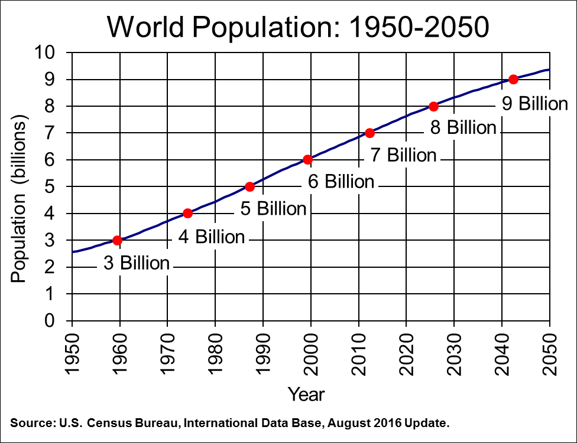

Fig 1. Population growth predictions by 2050

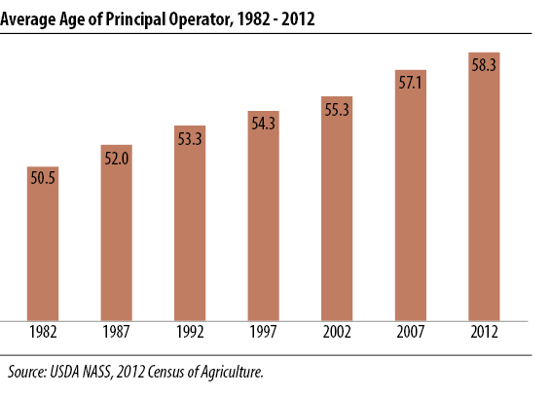

Fig 2. Average age of farmers (United States Department of Agriculture, 2014)

# Fortunately, today’s technology creates opportunities for avoiding this result with more autonomous, precise and cheaper farming solutions.

# Literature Survey

## 2.1 Technologies in farming

## There are various new technologies that are used in agricultural fields. However two main approaches can be observed through different system that is developed in last decade.

One of them is autonomous modular vehicles that proceed in open farms and performs various tasks like, grubbing, spraying herbicides, irrigating and transporting of tools. While most advantage of these systems is performing these tasks in autonomous way, also they increase productivity with being smaller than vehicle machines that are used in last decade like tractors and harvesters. Being smaller and modular is crucial for reducing crop rows, roads that are used for movement of farming vehicles without damaging plants. With narrower crop rows and less ground pressure of vehicles; active area of farms can be used more efficiently. (Corke, 2015)

Today there are lots of technologies in robotic vehicles for agricultural like Thorvald Platform; a small modular robotic vehicle which aimed to be used in future farming, Agbot; robotic vehicle for precision agriculture and Frobomind; an open software for creating autonomous vehicles. (Lars Grimstad, Cong Dung Pham, Huynh Nhat Trinh Phan, Pål Johan From, 2015) (Kjeld Jensen , Morten Larsen , Søren H. Nielsen 1, Leon B. Larsen, Kent S. Olsen and Rasmus N. Jørgensen , 2013)

Other technology that is common in field of farming is setups that cover whole area for applying autonomous tasks. These technologies are generally made for indoor and small garden applications. While indoor applications don’t give any solution for future farming problem; these technologies can be scaled up with using vertical farming. Moreover in future some of these projects can be scaled up for outdoor application.

One approach that is applied from MIT Lab, is creating artificial environment to grow wide range of plant kinds. This project aims to create a system that arranges factors affecting plant growth according to selected type plant of user. It is less autonomous in terms of tasks requires human interaction but more flexible in terms of possibilities for growing different plants regardless environment. (OpenAg)

Another technology providing an autonomous setup is created by an entrepreneur is Farmbot. Farmbot is more like a CNC machine or 3d printer that can achieve farming task. In this project a tool mount that can perform different task with different headers moves in three dimensions. (Farmbot)

## 2.2 Botany Research

Farming is one of the oldest inventions of mankind. Therefore today botany has an immense range of topics and a great scope of information. In order to avoid unnecessary information the research in this field was carried out by taking the operating and boundary conditions into consideration.

Vegetables or generally plants are divided into two categories depending on their harvest time which is either summer or winter. Since this project aims to have vegetables that could be harvested by Summer 2017, the seeds that will be planted will be of summer vegetables. Different seeds have different environmental needs to grow. Since there is limited time and space with this project, it is aimed to plant seeds that grow under similar conditions. Cucumbers (PH range: 5.5-6.5, Temperature: 20–30 °C and Growth Time: 55–65 days), tomatoes (PH range: 5.5-6.5, Temperature: 20–30 °C and Growth Time: 50-70 days), beans (PH range: 5.5-7, Temperature: 22–36 °C and Growth Time: 50-110 days), peppers (PH range: 5.5-6.5, Temperature: 22–30 °C and Growth Time: 60–95 days) can be considered as vegetables that grow under similar conditions (Somerville C, 2014)In addition carrots and other root vegetables such as beets and radishes has similar PH range of 6-6.5, temperature of 15-26 °C and growth time of 3-5 weeks. (Fritz, 2014)

Four of the vegetables that are mentioned above are selected based on their sowing and cutting/lifting time, germination temperature and average daily temperature. Broccoli, carrot, cabbage and lettuce are durable and resistant vegetables. One other reason that these vegetables were selected is rooting of these vegetables. Carrot in particular has a root that can grow to 600mm, because of this, length of the soil bed of the project was changed to 600mm which was smaller in the original project.

|  |  |  |  |  |  |  |
| --- | --- | --- | --- | --- | --- | --- |
|  | **Sowing Time** | **Planting Time** | **Cutting/Lifting Time** | **Rooting (mm)** | **Germination Temperature (°C)** | **Average Daily**  **Temperature**  **(°C)** |
| **Broccoli** | Apr-May | Jun-Jul | Aug-Oct | 300 – 450 | 25 | 13-18 |
| **Carrot** | Mar-Jul | - | Jun-Dec | 450 - 600 | 10-29 | 12-25 |
| **Cabbage** | Mar-May | May-Jul | Jun-Oct | 300 - 450 | 8-29 | 15-20 |
| **Lettuce** | Mar-June | - | Jun-Oct | 300 - 450 | 13-21 | 15 - 22 |

## 2.3 Closed Loop System with Step Motors

In this project, movements are made with Step Motors which are designed to be used in open-loop systems due to their non-linear magnetic property. However using feedback signals, desired system can be obtained to achieve position and speed precision. To obtain feedback signal; rotary encoders are used which gives position parameter of gantry and tool mount of system. For system control different method can be used like feedback linearization, sliding mode control, robust control, and backstepping control. (Duane Stort, Mark Ganter, Brian Fabieni, 2014)

In this project for controlling, feedback linearization will be used while there are not disturbance on system and overshoot can be tolerated.

**2.4 Image Processing**

Weeds are one of the harmful elements in agricultures. While today herbicides generally are used, in this system weeds will be pushed to underground via tool mount with weed detection using image processing. In farmbot system there is a camera on mount which monitories garden. With using short and long records of captures weeds can be detected in seconds consistently. Algorithms that can detect weed uses rgb color segment to differentiate weeds and ground. After eliminating earth from visual, it uses edge detection to match similar shapes that is introduced to program. (Ajinkya Paikekari, Vrushali Ghule, Rani Meshram, V.B. Raskar)

**2.5 Lighting**

Lighting is one of the key elements horticultural applications. Humankind made use of sunlight throughout the history with agricultural applications. Today, with advancements made in technology, humans are able to farm without sunlight. There are various options when it comes to lighting such as incandescent, fluorescent, HID and LED. Today LEDs are the most preferred lighting alterative when it comes to indoor farming applications.

LEDs were quite expensive back in the 80s when they were introduced for the first time as a farming solution and they only came in as red. Although green plants grew well under red light(660 nm), the plants were still under developed compared to plants that grew under sunlight. In a few years time blue LEDs were introduced and they were used along with red LEDs. The research showed that plants that grew under both red(600 to 700 nm) and blue(400 to 500 nm) showed more promising results and were as much as developed as plant that grew under normal circumstances. Green LEDs were added later in order to replicate sunlight and allow the researchers to detect any infections and diseases on the surface which were hard to identify under the combination of red and blue lights. (Gioia D. Massa, 2008)

Today LEDs are more affordable in contrast to earlier back in time. Although they are still more expensive in comparison to products of generic technology, it should be considered that LEDs have longer lifetime expectancy and lower energy consumption rates compared to other alternatives. (Bourget, 2008) It could be said that LEDs are long-term investments.

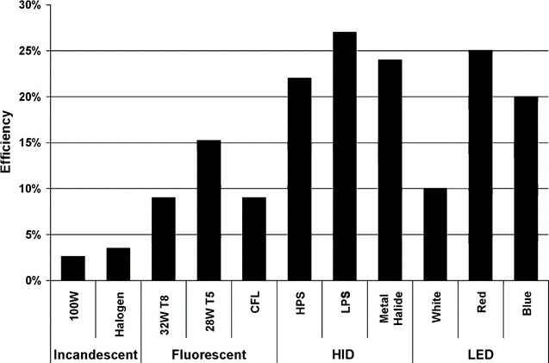

Efficiency Comparison of Lighting Systems

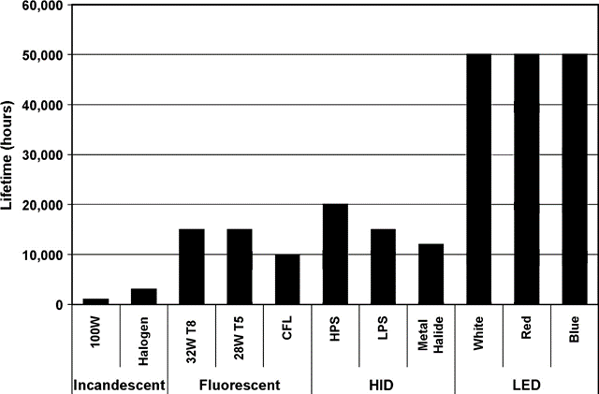

Lifetime Expectancy of Different Lighting Systems

# Definition of the Project

Aim of this project is designing and prototyping a replica of Farmbot project. Farmbot is a complete autonomous setup for performing farming tasks like seeding, irrigating, removing weeds and measuring moisture of soil. Also system has camera for achieving some of these tasks, monitoring plant evolution and recording whole growing process. All of these tasks are made with a tool mount which is compatible with different tools. This tool mount can transform in three axes with gantry robotic system.

While the project is building a replica system of an open-source machine, whole design and analyze processes are in scope. This is due to aim of reducing cost, increasing efficiency and aim of modification implementations on design according to objectives. The project will be an indoor farming solution that uses LEDs for lighting needs. It could be said that this project stands between Farmbot Genesis and MIT’s Open Agricultural Initiative.

## 3.1 Objectives

The objective of the project is designing and building a prototype of a robotic farm system. Additionally, analyzing results of prototype which means examining growth plants is also in scope of this project. Prototype will have capability of growing plants all by itself without human interaction. Also, the prototype will be adjustable in terms of size with applying small changes.

## 3.2 Boundary Conditions and Operating Conditions

The boundary conditions and operating conditions of the above mentioned design objective are provided in Table 1.

|  |  |
| --- | --- |
| **Operating conditions** |  |
| Soil PH | 5.5 - 7 |
| Light | Full Spectrum LED Lights(400 nm – 700 nm) |
| Moist | Will be adjusted according to each plant’s needs |
| Temperature range(°C) | 20-25(Germination)  15-20(Growing) |
| Stress | (Analyzed in the design section) |
| **Boundary conditions** |  |
| Volume range | 30 rpm |
| Speed of Gantry robotic arm | 100 m |

Table 1 Operating and boundary conditions

## 3.3 Constraints

This project has some challenges and constraints in terms of technical aspects, economical aspects and physical applicability.

While robotic technologies include wide range of different disciplines, some technical area won’t be involved in advance. For building a working prototype; applications require knowledge of those disciplines will be obtained from FarmBot’s open source project. Mostly those technical areas will be related to software platform of prototype like image processing, web and application interfaces and computational system design.

This project is granted with 400$. However the firm who build this project commercially sells it by around 3000$. According to components list and research raw cost reduced to 500$ which also exceeds granted price. However this cost can be reduced with obtaining hardware components like step motors, single-board computer and microcontroller; from individual resources of project owners.

Even so this project based on robotics, it is also depends on botanical factors. These factors creates some constrains to system. While this system can’t simulate all kind of environments; its capability of growing plants depends on environmental factors. Event humidity, temperature, light can be arranged according to needs of plants up to a point; it can’t provide these factors in all levels. Factors that excluded from scope of project also bring some limitations; like sickness of plants, insects etc…

There are no social and ethical constraints and concerns about this project.

# Methodology

## 4.1 Analysis method

Analyze process will be made iteratively before starting to build system during design process.

Following aspects aimed to be analyzed:

* Stress analysis of rails and gantry frame analytically.
* Analytic predictions of control systems.
* Design analysis with numerical methods using special software..
* Numerical analysis of control systems. (Numerical analysis aimed to be performed with Python(x,y))
* Experimental analysis of planting with general methods before starting to planting using farmbot.

## 4.2 Design method

Project is currently under design. Various changes have been made to the original system and the design was changed accordingly. The design is subject to change in the future.

# Work packages and Time Plan

Table 1 shows time line of project with work packages and task distribution between project owners.

|  |  |  |  |  |  |  |  |  |  |
| --- | --- | --- | --- | --- | --- | --- | --- | --- | --- |
|  | Oct | Nov | Dec | Jan | Feb | Mar | Apr | May | Task Distribution |
| Background Research |  |  |  |  |  |  |  |  | Ali – Umur |
| Evaluation and Deciding on Project |  |  |  |  |  |  |  |  | Ali – Umur |
| Literature Survey |  |  |  |  |  |  |  |  | Ali – Umur |
| Deciding on Design Methodology |  |  |  |  |  |  |  |  | Ali – Umur |
| Preparing and Confirming Component List |  |  |  |  |  |  |  |  | Ali – Umur |
| Mechanical Design |  |  |  |  |  |  |  |  | Ali – Umur |
| Software Design |  |  |  |  |  |  |  |  | Ali – Umur |
| Design and Thermal Analysis |  |  |  |  |  |  |  |  | Ali – Umur |
| Purchase of components and hardware |  |  |  |  |  |  |  |  | Ali – Umur |
| Building system |  |  |  |  |  |  |  |  | Ali – Umur |
| Software integration |  |  |  |  |  |  |  |  | Umur |
| Test - Planting |  |  |  |  |  |  |  |  | Ali – Umur |
| Analysis of Results (Harvesting) |  |  |  |  |  |  |  |  | Ali – Umur |

Table 2 – Gann Chart

# Design

1. **Overall Design**

The need of led system in setup created a limit on height of gantry. In original design of farmbot; a lead screw is used for elevation of universal tool mount. This system enables freedom of UTM in Z-axis. While this design is simplest and efficient solution for movement it creates variable height. In this design height varies between 850mm – 1550mm.

However led system that is placed on top of crane in current design; limits the maximum height of power screw. This limitation appears due to need of efficiency of LEDs. For taking advantage of light that is emmited from LEDs; system must be close to plants as much as possible. Therefore in new design a different approach is used.

For obtaining Z-axis movement; instead of lifting UTM itself; whole crane is designed as subject of Z movement. This design achieved with using 2 lead screws with one additional motor. These lead screws are sharing the weight of horizontal component while enabling it to rise and descent. In modified design whole system without case and led parts has height of 840mm. With that height, led system can be placed to 950 mm far of plants.

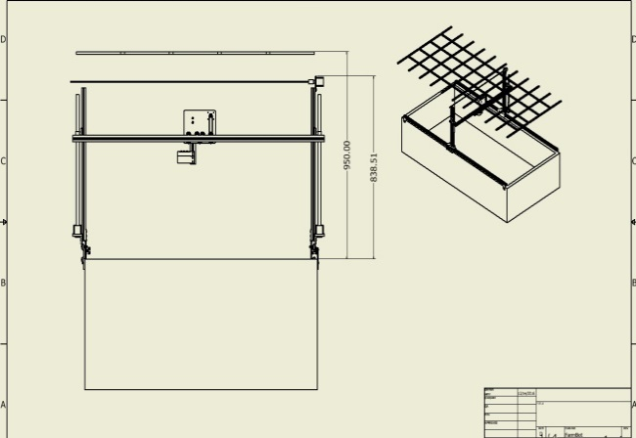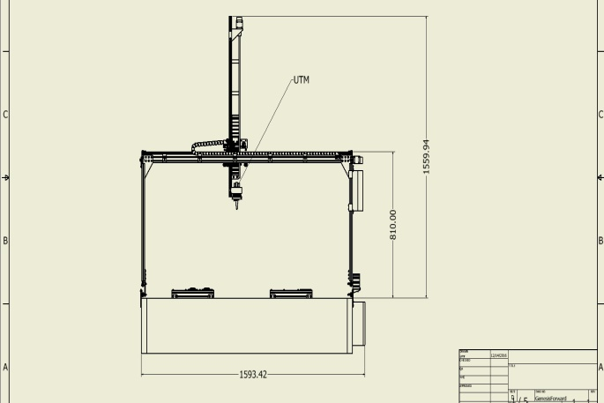

Figure 1 – Farmbot design Figure 2 – Modified Design

1. **Analysis of Critical Components**

In stress analysis of design, connection points and important structural elements are taken as subject. As a structural elements header track and lead screw are analyzed.

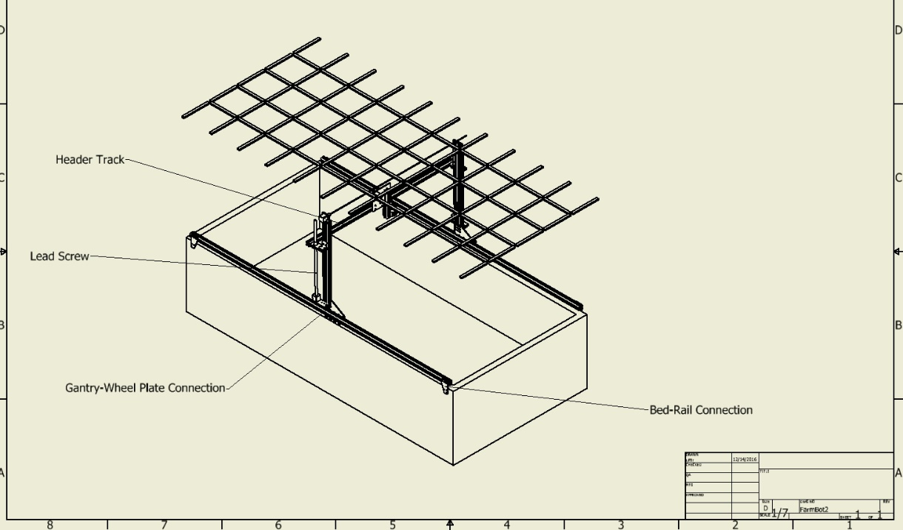

Figure 3 – Critical Components

In stress analysis of component; distortion energy theory for ductile materials are used while this method is applicable for metals. According to this theory, yielding occurs when distortion stress energy per unit volume exceeds distortion stress energy per unit volume for yield in tension or compression of the same metal. In other words strain energy per unit of components is limited to their materials’ yield strength. This value can be found von Mises stress formula. (Richard G. Budynas, J. Keith Nisbett, 2015)

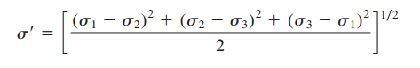

Equation – 1 von Mises stress formula

1. **Stress Analysis**

ALİ BURAYI GÜNCELLE. MOTORLARLA ALAKALI BİR ANALİZ YAP. BEN SANA MOTORLARIN MODELİNİ ATICAM. EN AZINDAN KANITLA MOTORLARIN YETERLİ OLUCAĞINI VE SHAFTIN ONA DAYANACAĞINI.

Material of connection parts are chosen as stainless steel for longevity and durability.

Material of extruded parts is made from Aluminum 6063 T-6 as specified by reseller.

|  |  |
| --- | --- |
| Yield Strength (MPa) | 220 |
| Ultimate Strength (MPa) | 601 |

Table 1 - Stainless Steel Annealed Material Properties (Richard G. Budynas, J. Keith Nisbett, 2015)

|  |  |
| --- | --- |
| Yield Strength (MPa) | 210 |
| Ultimate Strength (MPa) | 250 |

Table 2 - Aluminum 6063 T-6 (6063 T-6 Aluminum, 2016)

Analysis of components made with maximum force that will be applied during operation of system. Safety factor is taken as 5.

|  |  |  |  |  |
| --- | --- | --- | --- | --- |
| Component Name | Applied Force (N) | Max Von Misses Stress (MPa) | Yield Strength (MPa) | Maximum Allowable Stress (SF=5) (MPa) |
| Gantry-Wheel Plate Connection | 200 | 24.65 | 220 | 44 |
| Bed-Rail Connection | 400 | 11.56 | 220 | 44 |
| Header Track | 200 | 34.26 | 210 | 42 |

Table 3 -Stress Analysis Results

1. **Power Screw Analysis**

Power screws are devices that changes angular motion to linear motion. While power screws are generally used for elevation, it must resist to gravity for preventing self-lowering. This creates a need for analysis.

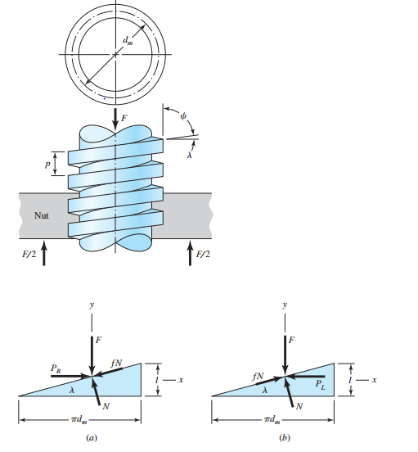

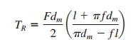

Figure 2 - Self-lock condition formula derivation (Richard G. Budynas, J. Keith Nisbett, 2015)

Power screw resists unintended descent with help of frictional force. This makes frictional force as most critical parameter in power screw design, which depends on angle of screw and material of screw and nut. With static force analysis TR and TL can be calculated which are respectively required torque for lifting and lowering. If TL is equal or less than zero, nut will slip on screw by itself. This condition can be checked with last formula on Figure-2. While this formula is not depends normal force, self-locking doesn’t depend on applied force.

According to self-locking condition, designed power screw’s self-locking condition is confirmed.

1. **Thermal Analysis**

**todo**

# Universal Tool Mount Design

Universal Tool Mount is one of the main components of farmbot system. It is designed as that it can be compatible with unlimited number of tools.

Connection between tools and UTM is made by magnets. Both UTM and tools have ring magnets that create attraction forces. Detachment is made by tool bay which grips tools from special gaps. For reducing attraction force between magnets, springs are placed under UTM which enables more convenient detachment.

Data transition İS made by conductive screws. In design of UTM there is 12 screws which is connected 12 different ports of arduino that is passed from middle cable placed in the center of UTM. While tools are attached to UTM their screws touches which creates connection between tool data ports and UTM parts. With that design 12 different ports can be used for data transition. For example tool that measures humidity uses two ports.

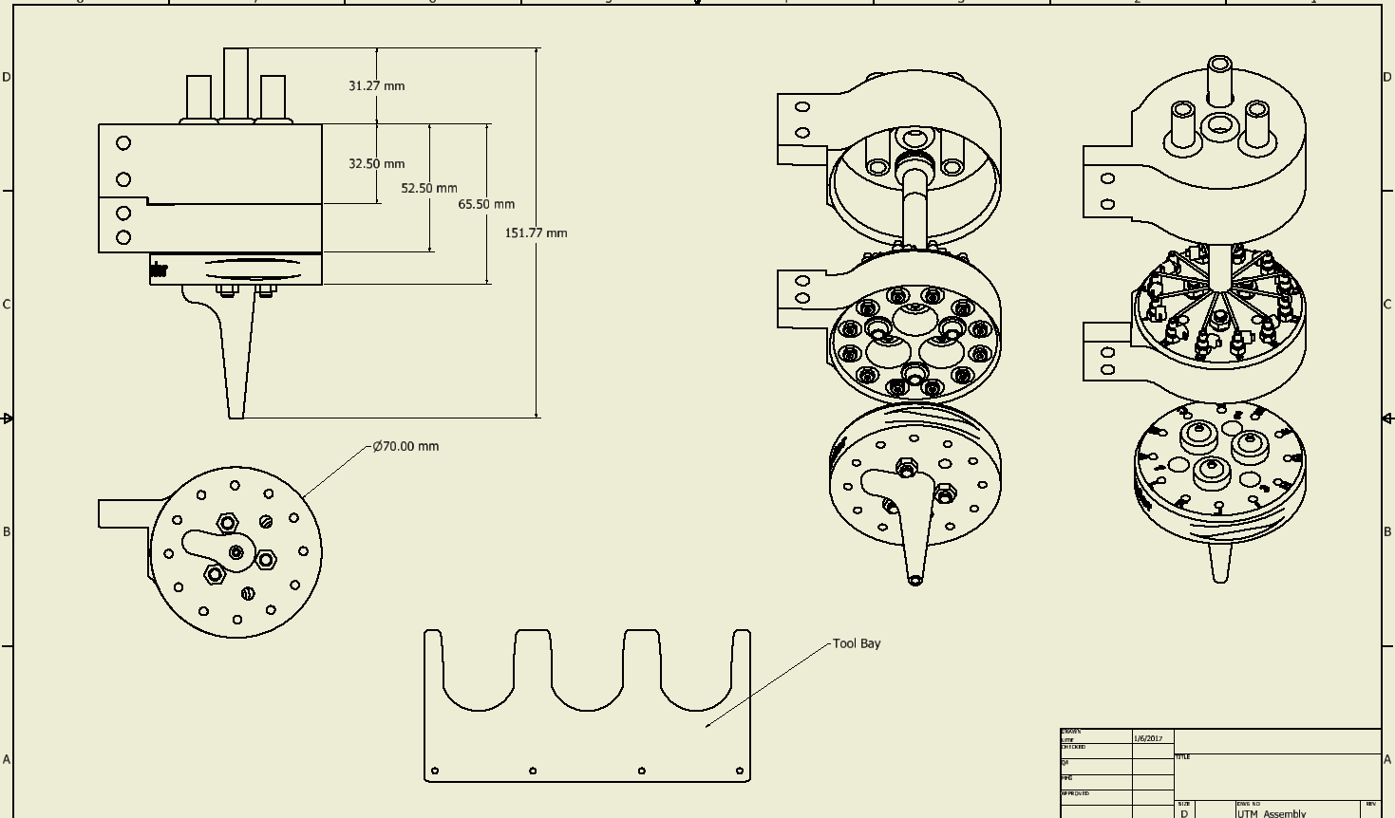

Figure 4 – Universal Tool Mount Design and Tool Bay

Figure 5- TOOLS ALİİİİ EKLEEEEEE

1. **LED System**

One of the elements that makes this project like a greenhouse is light control.

With reflective walls, light is completely under control of system. For achieving long life, efficient and reliable light conditioning led tubes having full spectrum of sun are used in design. For placing these light tubes a plate that is supported by rods is designed. Actual reason of choosing these led tubes is the cost. These tubes can be bought from suppliers 5-8 $ per piece. While all the led system will be opened and closed at the same time one controller will be enough to achieving aimed result.

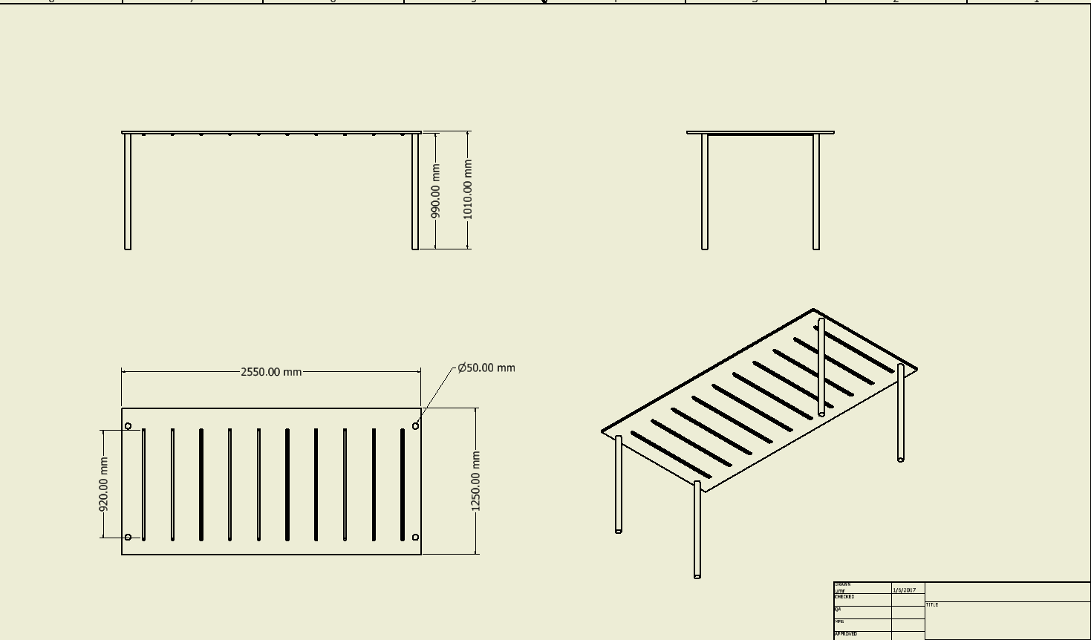

Figure 6 – LED System Structure

# Software Design and Algorithms

In this project, software algorithms are crucial while it is the key element of autonomous.

For controlling electronic elements of farmbot arduino; a microcontroller will be used which is also controlled by raspberryPi; a small portable linux based computer. Between arduino and raspberryPi, python will be used as interface. And whole algorithms for fambot will be written in python.

Software design will be separated as two module; controller module and ai module. Controller module will be includes methods that is used for controlling utm and other electronic elements while ai module will be include algorithms and variables settings for autonomous side of farmbot. With that design, ai module will be communicate with controller module all the time during mission and user also will be able to manually control system with using controller module from secure shell command line.

|  |  |  |
| --- | --- | --- |
| Controller Module Methods | AI Module Method | AI Module Variables (User Settings) |
| move_UTM(float displacement, int axis) | move_grid(int grid_id) | float day_and_night_ratio |
| set_fan_rpm(float rpm) | change_tool(int tool_id) | float optimal_temperature |
| set_exhaust_rpm(float rpm) | plant_seed(int seed_id, int grid_id) | dictionary<int,float> lowest_hummidty_level |
| led_system(bool on_off) | water_grid(int grid_id) | int weed_factor |
| vacuum(bool on_off) | get_overall_status() |  |
| water(bool on_off) | get_plant_status(int id) |  |
| resistance(bool on_off) | push_weed(float x,float y,float z) |  |
| get_hummidity() | scan_for_weed() |  |
| get_color_plant() |  |  |
| get_size_plant() |  |  |
| scan_weed() |  |  |
| record(bool on_off) |  |  |

Table 4 – Overview of base methods and variables of software design

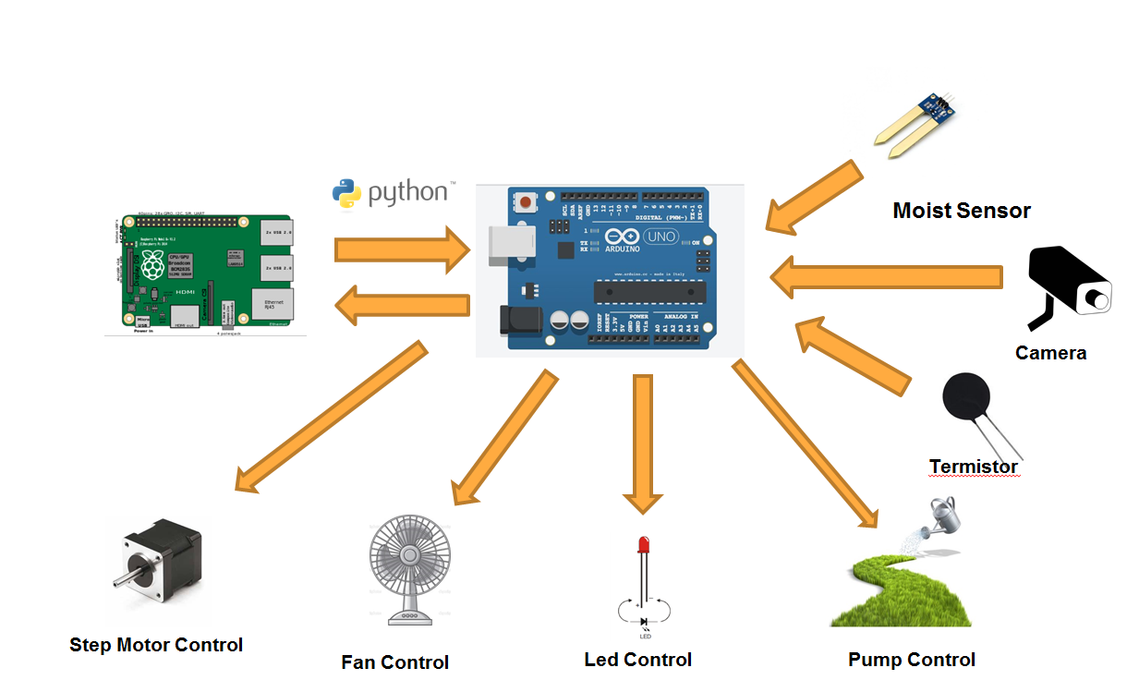

Figure 4 – Overview of relation between hardware and software

For image processing side, OpenCV library will be used in this project. OpenCV is an open source library that is written for computer vision. It has interface for python and very suitable for farmbot setup. With capability of this library weed detection, tracking plant growth will be achieved. (OpenCV Developers Team)

# Cost Analysis

Cost analysis reviewed through design of project. It is separated according to classifications of components. At the beginning of project cost was nearly 600$, however changing some materials, finding cheap LED suppliers and obtaining some parts from existing components; it could be reduced under the 400$.

|  |  |  |
| --- | --- | --- |
|  | TR | Dolar |
| Extrusions | 158.370569 | 44.23759 |
| Fasteners and Hardware | 24.29642 | 6.786709 |
| Drivetrain | 458.152 | 127.9754 |
| Electronics and Wiring | 567.57 | 158.5391 |
| Tubing | 70 | 19.55307 |
| Miscellaneous | 117.2 | 32.73743 |
| Raised Bed | 10 | 2.793296 |
| TOTAL | 1405.588989 | 392.6226 |

Table 5 – Cost Analysis

Acknowledgements

This project is based on Farm Bot open source project that is developed by FarmBot Inc. (Farmbot)

References

*6063 T-6 Aluminum*. (2016, 8 6). Retrieved from Makeitfrom: http://www.makeitfrom.com/material-properties/6063-T6-Aluminum

Ajinkya Paikekari, Vrushali Ghule, Rani Meshram, V.B. Raskar. (n.d.). *WEED DETECTION USING IMAGE PROCESSING.*

Bourget, C. M. (2008). An Introduction to Light-emitting Diodes.

Corke, P. (2015, 11 13). Robots in agriculture. *[Video file]. Retrieved from https://www.youtube.com/watch?v=Q69RVHy-Xbw*.

Duane Stort, Mark Ganter, Brian Fabieni. (2014). *Closed-Loop Control of a 3D Printer Gantry.*

Farmbot. (n.d.). Retrieved from Farmbot: https://farmbot.io/

Fritz, V. A. (2014). *Growing carrots and other root vegetables in the garden*. Retrieved from http://www.extension.umn.edu/garden/yard-garden/vegetables/growing-carrots-and-root-vegetables/

Gioia D. Massa, H.-H. K. (2008). Plant Productivity in Response to LED Lighting. *HortScience*.

Harper, C. (2015, 10). This computer will grow your food in the future. *Video file]. Retrieved from http://www.ted.com/talks/caleb_harper_this_computer_will_grow_your_food_in_the_future*.

Kjeld Jensen , Morten Larsen , Søren H. Nielsen 1, Leon B. Larsen, Kent S. Olsen and Rasmus N. Jørgensen . (2013). *Towards an Open Software Platform for Field Robots in Precision Agriculture.*

Lars Grimstad, Cong Dung Pham, Huynh Nhat Trinh Phan, Pål Johan From. (2015). *On the design of a low-cost, light-weight, and highly versatile agricultural robot.*

OpenAg. (n.d.). Retrieved from Open Agriculture: http://openag.media.mit.edu/

Richard G. Budynas, J. Keith Nisbett. (2015). *Shigley's Mechanical Engineering Design.* New York: McGraw-Hill Education.

Somerville C, C. M. (2014). Small-scale aquaponic food production.

United States Department of Agriculture. (2014, 5). *Farm Demographics - U.S. Farmers by Gender, Age, Race, Ethnicity, and More.* Retrieved from Census of Agriculture: https://www.agcensus.usda.gov/Publications/2012/Online_Resources/Highlights/Farm_Demographics/

V, F. (n.d.).

White, B. (2012). *Agriculture and the Generation Problem: Rural Youth, Employment and the Future of Farming.*